|  |  |
| --- | --- |
| Course Name | ITD 2313 – Script Programming |
| Instructor | Michael Schnell |
| Student Name | Samantha Ramsey |
| Due date | January 29, 2023 |
| Grade | Put grade earned here |
| Grading Comments | Put instructor comments here |

# Using Functions and Modules

## Calling Functions, Arguments, and Return Values

### Page 55

1. The first example code is the help line near the top of the page.

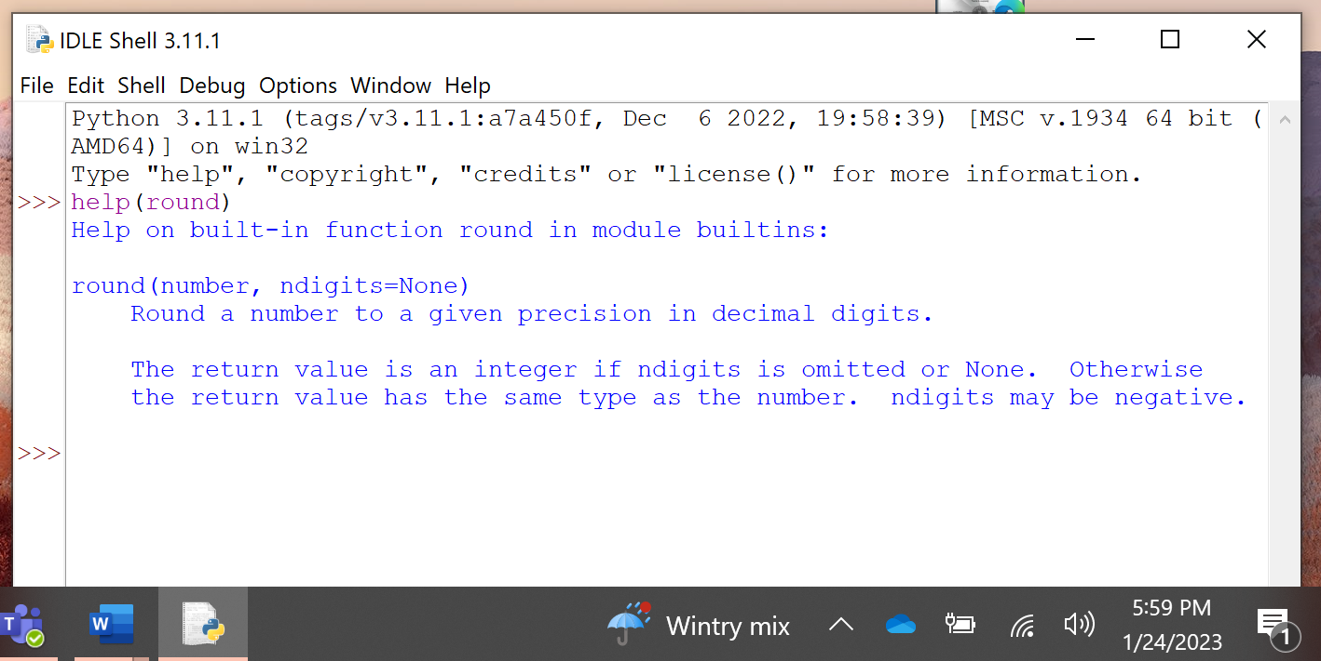

1. The second example code set is in the math module subsection about 3/4 down on the page.  You need to do this step before doing any of the code examples on page 56

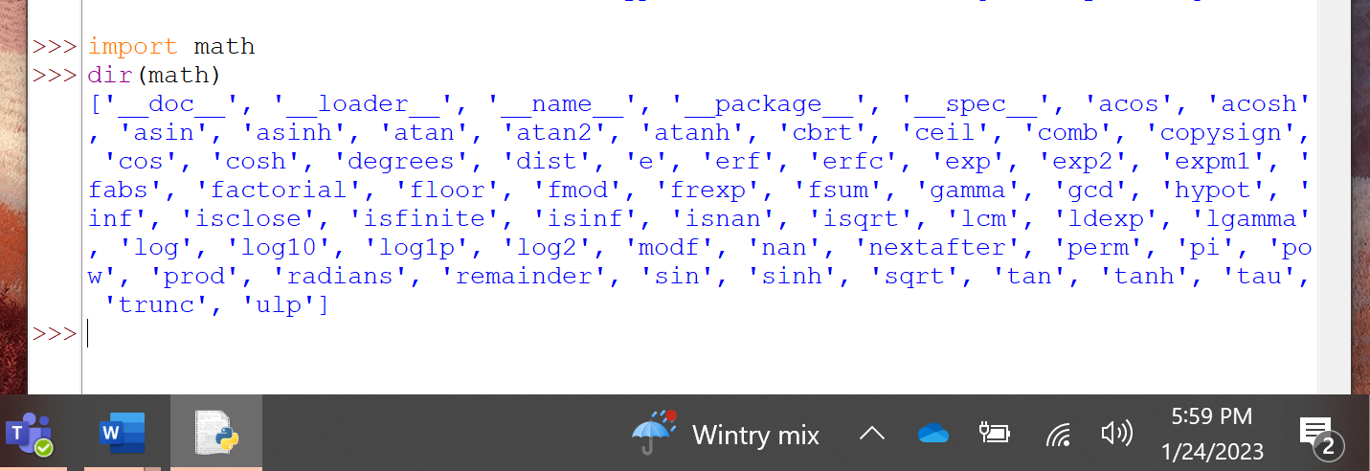

### Page 56

1. The first code example is near the top and has you working a little with the math module
2. The second code set is a little below the first and again utilizing the help feature but this time with a math module function
3. The third code example for the page shows the import functionality with just a select few items

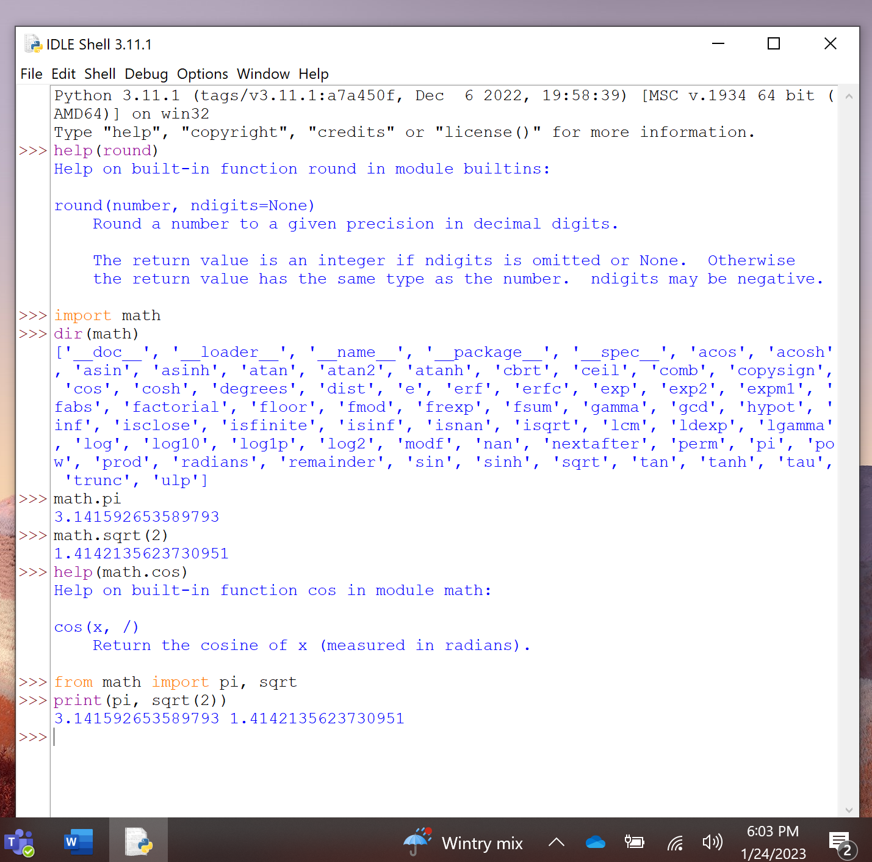

1. The last item on the page shows you how to import a Python program as a module.  You will need to have downloaded the file in the resources for the week section of the class for this one.

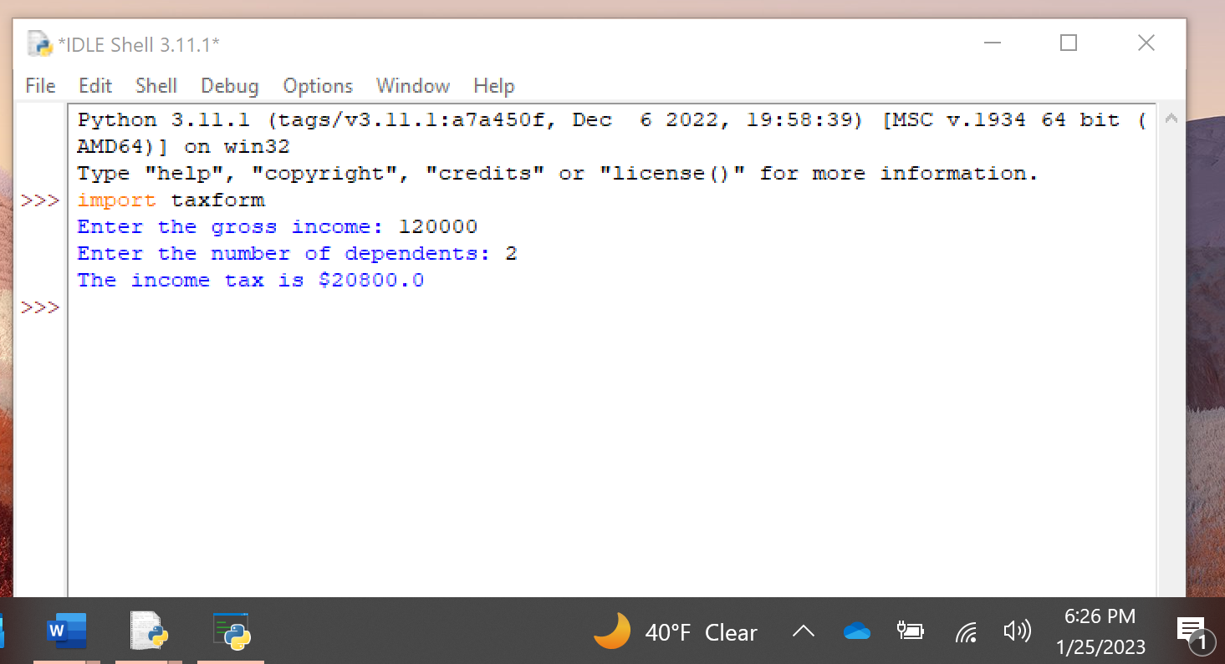

## The Main Module

### Page 57

1. The last item on page 55 showed you how to import a python program and the first item on this page shows you how to use help with that imported item.